**Experiment No.07**

**Nested Control Structures**

**OBJECTIVE**:

• To be able to understand the working of nested control structures. 

**Exercise –1 (5 points)**

Write a program that uses nested for – loops to print first 10 entries of tables of 1 to 10. For example the first 10 entries of tables of 1 to 5 are given below in figures 1 & 2.

#include <iostream>

using namespace std;

int main()

//////{

////// for(int i=1;i<=10;i++){

////// cout<<"--------Table of "<<i<<"----------"<<endl;

////// for(int j=1;j<=10;j++){

////// cout<<i<<"*"<<j<<"="<<i*j<<endl;

////// }

////// }

//////}

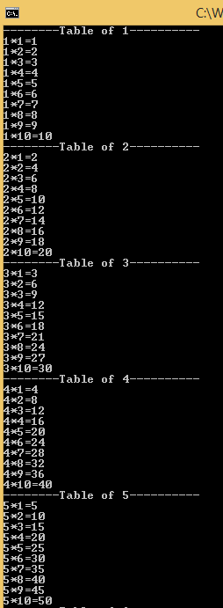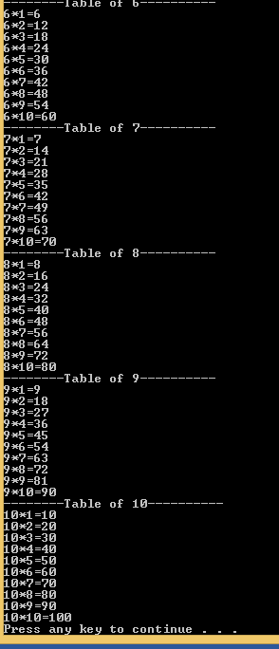

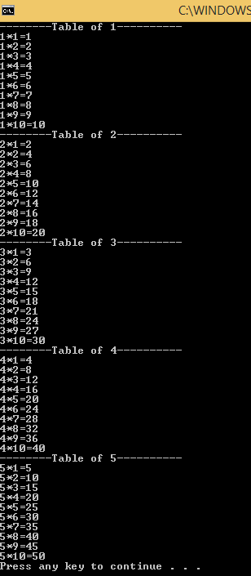 **Exercise –2 (10 points)**

Write a C++ program that takes 2 integers (i) a starting number and (ii) the number of elements in last row. Then print the data in form of a lower triangular matrix.

{ int a,b;

cout<<"enter the starting number"<<endl;

cin>>a;

cout<<"eter the elemens in last row"<<endl;

cin>>b;

for( int i=1; i<=b;i++){

for(int j=1;j<=i;j++){

cout<<a<<" ";

a++;

}

cout<<endl;

}

}

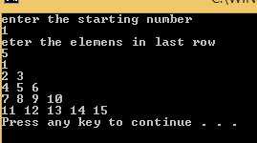

**Exercise –3 (10 points)**

Design and write a C++ program that takes as input an integer larger than 1 and calculates the sum of the squares from 1 to that integer. The output should be the value of the squares and the sum, properly labelled on the screen.

For example, if the integer equals **“4”**, your program would display:

1

4

9

16

Sum=30

{

int a,b,sum=0;

cout<<"enter the number"<<endl;

cin>>a;

for(int i=1;i<=a;i++){

b=i*i;

cout<<b<<endl;

sum=sum+b;

}

cout<<"sum="<<sum<<endl;

return 0;

}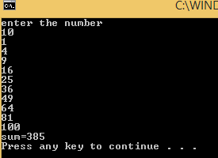

**Post lab:**

Write a program to calculate the place value of digit in an integer.

For example, if the user inputs an integer **“6918”** and you want to determine the place value of 6, the output would be “Thousands”. You can include a check for whether that specific digit is present or not. Your program should work for a maximum place value of “thousands”.

*Units; tens; hundreds; thousands

#include <iostream>

using namespace std;

int main()

{

int a,b,c,d,i=0;

bool n;

cout<<"enter the number";

cin>>a;

cout<<"enter the number to find place";

cin>>d;

n=true;

while(a){

b=a%10;

i++;

a=a/10;

if(d==b){

n=false;}

else if(a==0){

i=5;

break;}

else

continue;}

switch(i)

{

case 1:

cout<<d<<"is unit place"<<endl;

break;

case 2:

cout<<d<<"is tense place"<<endl;

break;

case 3:

cout<<d<<"is unit place"<<endl;

break;

case 4:

cout<<d<<"is thousand place"<<endl;

break;

default:

cout<<"invalid number u enter"<<endl;}

return 0;

}

